Administrative Unit Assessment Frequently Asked Questions
(Click on a question below to be taken to the reply)
Table of Contents
What is the purpose of administrative unit assessment? 2
How should our unit choose AUOs? 2
Our unit is currently in a time of transition. How can we participate in administrative unit assessment in a meaningful way during this period? 2
Who will be able to access and see our administrative unit assessment reports? 2
Should our unit create new Administrative Unit Outcomes (AUOs) every year? 3
Our unit just developed a new strategic plan, and we want to create all-new AUOs to align with our plan. Is this okay? 3
How do we develop effective, high-quality AUOs? 4
How specific do our targets need to be? 5
Does our unit need student learning outcomes (SLOs)? 6
How do we create direct measures for our SLOs? We have a survey that asks students if they feel that they’ve learned something from our program, is this a direct measure? 7
Our unit is ready to write our report. When do we need to include Comments on Findings, Action Plans, and Comments on Past Action Planning? 8
What do we do with the feedback we receive from Institutional Effectiveness? 10
Do we need to resubmit our annual report after we receive feedback from Institutional Effectiveness? 10
Our unit has created AUOs, measures, and targets, but we want to be sure we’re on the right track before we start collecting data. Is there a way to get feedback before we submit the annual report? 10
Our unit is still has questions. Can we get some extra help? 10

What is the purpose of administrative unit assessment?

The purpose of administrative unit assessment is to collect data that your unit will USE to make decisions about how to get better at what you do. Some key points:

- This process is about seeking improvement, not about demonstrating performance.
- If the data collected are never used, then this becomes a pointless exercise. If a unit is measuring something that they have already optimized, then this becomes a pointless exercise. And there’s nothing worse than a pointless exercise!

How should our unit choose AUOs?

Your unit should choose AUOs that will provide data you are interested in and will answer questions that your unit is asking. Here are some guiding questions to help think through possible AUOs:

- What barriers or challenges to satisfying your mission is your unit currently or consistently grappling with?
- What trends does your unit see coming down the pike that you want to start preparing for now, so you stay on top of your game?
- What questions do you and your team keep coming back to, but haven’t found a satisfying answer to yet?
- What relationships or partnerships does your team need to build?
- What skills does your team need to build?
- What could your team do or examine so it is focusing on prevention instead of reaction?
- What metaphorical rocks do you need to look under to prevent surprises?

Our unit is currently in a time of transition. How can we participate in administrative unit assessment in a meaningful way during this period?

Units that are currently moving or restructuring can still benefit from the administrative unit assessment process. During this time, when a unit’s mandate or responsibilities may be in flux, it may be helpful for AUOs to focus more on internal processes and team function, such as:

- Team member participation in professional development
- Team member participation in diversity, equity, and inclusion activities
- Tracking efforts to create greater work-life balance for team members
- Collecting data on customer satisfaction with services or resources provided (even if the services or resources change, the unit will have useful data that demonstrates their effectiveness)
- Team member participation in community service activities

Who will be able to access and see our administrative unit assessment reports?

Institutional Effectiveness archives all submitted administrative unit assessment reports so that documentation is preserved through leadership changes and for SACSCOC reporting purposes. A unit’s report can only be requested by the senior leadership to whom it reports. All reports are available for review by SACSCOC representatives during the university’s 5- and 10-year reaffirmation processes.

Sometimes, units submit high-quality outcomes that would make good examples for others to see. In these cases, Institutional Effectiveness will contact your unit head and obtain permission to share a de-identified version of your outcome.

Should our unit create new Administrative Unit Outcomes (AUOs) every year?

The goal of administrative assessment is to demonstrate how our administrative units improve over time. If units create all new AUOs every year, it will not be possible to illustrate the effects of the unit’s efforts to improve its processes, services, or products. Well-crafted AUOs should be applicable to activities of the unit over several years.

However, there are a few instances where units will need to change some of their AUOs:
- They have met their targets for their existing AUOs for many years in a row, and would now like to focus on improving other processes, services, or products.
- They have developed a new strategic plan, and want to align their administrative assessment with their new plan.
- They have realized that some of their current AUOs are no longer useful for helping them improve.

Our unit just developed a new strategic plan, and we want to create all-new AUOs to align with our plan. Is this okay?

Yes, it is good practice to align your administrative assessment efforts with your unit’s strategic or operational plan. It is best if your unit can align some of your previous AUOs with current activities, and you will want to make sure that your new AUOs are structured so that they will be useful to your unit for several years. For advice on how to do this, please see “How do we develop effective, high-quality AUOs?” below.

How do we develop effective, high-quality AUOs?

Each unit should have 3-5 AUOs, and measure at least three every year. Your unit’s AUOs should be:
- Focused on the processes, services, and/or products that your unit would like to improve.
- High-level enough that they can be used over multiple years to guide continuous improvement.
- Specific enough that they are actually measurable.
- Derived from the mission or mandate of your unit.
- Related to things that your unit can actually control.

Here are some examples:

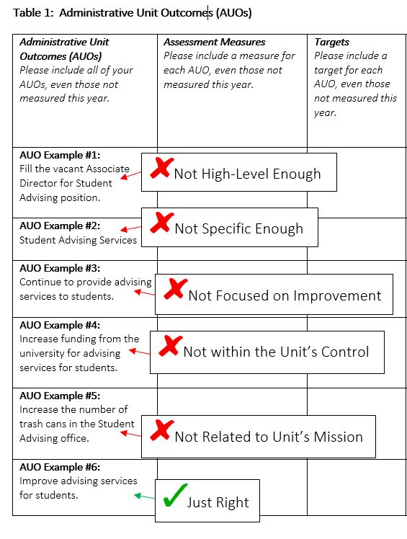

How specific do our targets need to be?

The more specific your targets are, the better they will demonstrate improvement over time. Here are some examples of both good and bad targets:

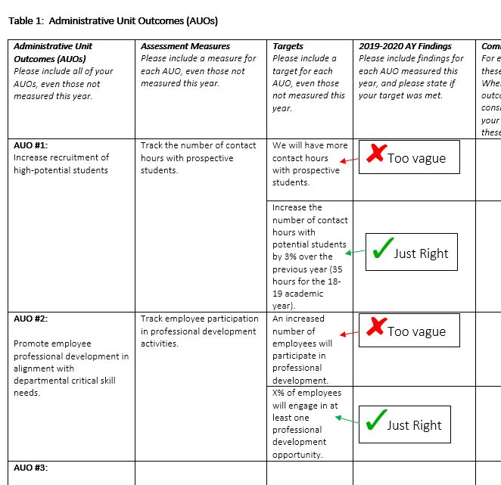

Does our unit need student learning outcomes (SLOs)?

For units that are responsible for delivering content to students, we consider these units to have instructional responsibilities. Units with instructional responsibilities should create at least one student learning outcome as a part of their administrative assessment process, and should create at least one direct measure for any SLOs.

Important note: For student programs or services where the expected outcomes relate to student attitudes, confidence, motivation, etc., these outcomes should be represented in an administrative outcome and should not be represented in a student learning outcome.

SLOs should:
- Be focused on the knowledge/skills/abilities that students will be able to demonstrate as a result of interacting with your program or service.
- Be detailed enough to be measurable.
- Include a direct measure of student learning, where students are required to demonstrate their new knowledge/skills/abilities (the next question below provides more information on how to develop direct measures).

Here are some examples:

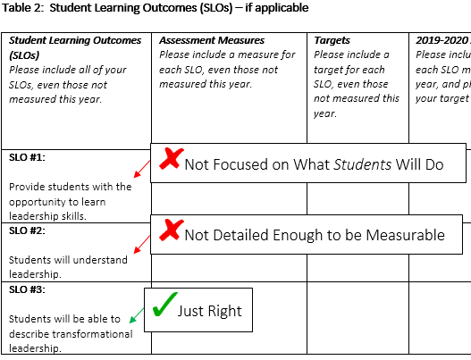

How do we create direct measures for our SLOs? We have a survey that asks students if they feel that they’ve learned something from our program, is this a direct measure?

A survey of students’ opinion of their learning is not a direct measure. Direct measures require students to demonstrate their learning.

For administrative units, direct measures can be:
- Pieces of student work evaluated through a rubric, including papers, presentations, and other performances.
- Test questions with right or wrong answers.

Most administrative units with instructional responsibilities do not require students to create papers or presentations, so using a rubric will only be appropriate for some units. However, most units with instructional responsibilities already give student surveys at the end of sessions or experiences. In these cases, test questions can be added to the existing survey to serve as direct measures. Here are some examples:

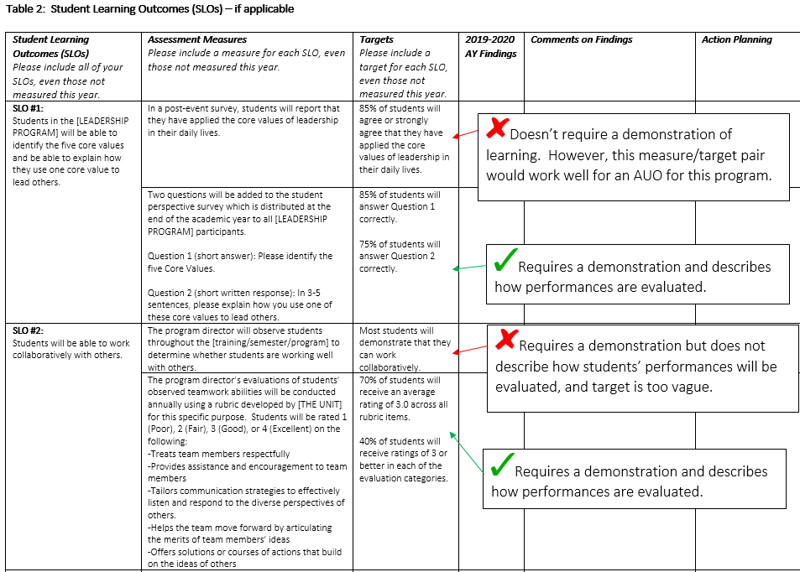

Our unit is ready to write our report. When do we need to include Comments on Findings, Action Plans, and Comments on Past Action Planning?

The last four columns of the template are designed to guide administrative units through a process of reflecting on their findings and determining what to do based on this information. Here is an example for the Findings column:

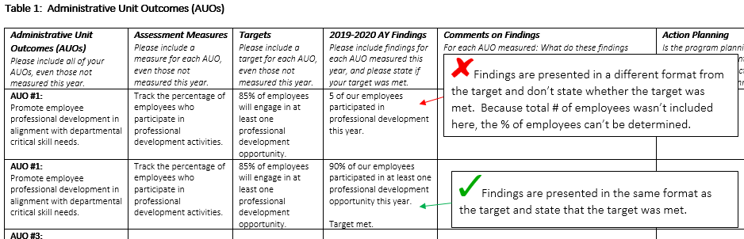

For any outcome where findings are presented (since not all outcomes must be measured every year), units should use the Comments on Findings column of the report template to add context to their findings. The goal of this column is to document how units make sense of their findings.

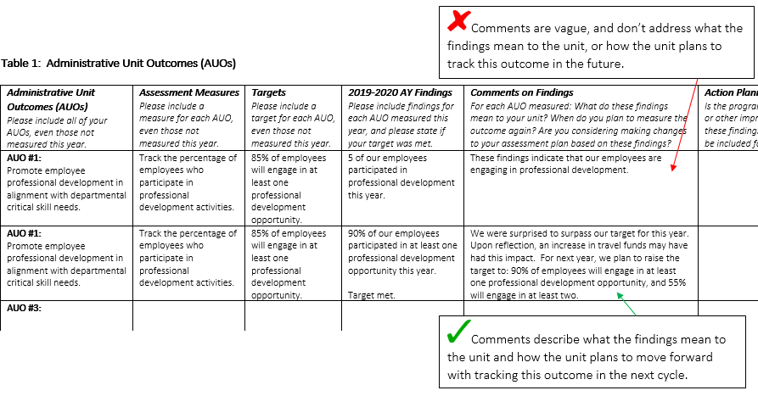

The Action Planning column is designed to help units document the decisions they make to improve. For all outcomes where the target is not met, the unit should include an action plan. If all targets are met, then at least one action plan should be included on any outcome the unit wishes to improve.

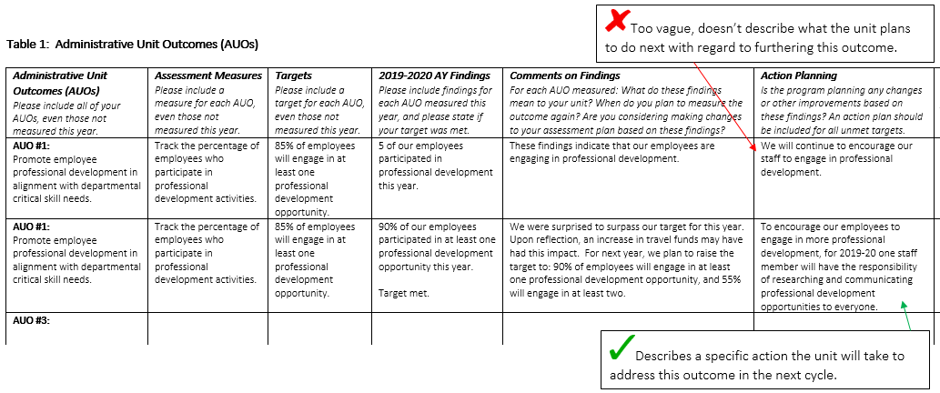

Comments on Past Action Planning is where units should document the outcomes of previous action plans for this unit. If this is a new outcome, then previous action plans may not exist.

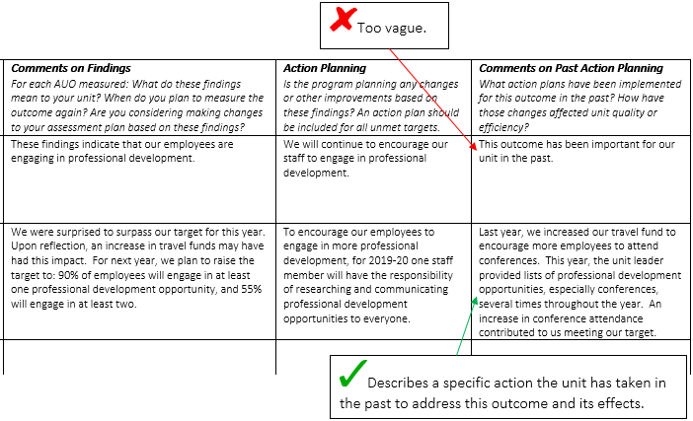

What do we do with the feedback we receive from Institutional Effectiveness?

Every report submitted to Institutional Effectiveness goes through a double-review process, where it is reviewed by two different staff members who embed feedback directly into the report. This feedback is given to assist the unit in improving its assessment processes, and is intended to be used to inform the next cycle of assessment. Please refer to this feedback as you finalize your assessment plan and report for the next cycle.

Do we need to resubmit our annual report after we receive feedback from Institutional Effectiveness?

No, administrative units do not need to resubmit their reports after they receive feedback from Institutional Effectiveness. This feedback is provided purely to help the unit improve its processes for future cycles.

Our unit has created AUOs, measures, and targets, but we want to be sure we’re on the right track before we start collecting data. Is there a way to get feedback before we submit the annual report?

Institutional Effectiveness is happy to provide feedback at any point. This includes providing feedback on outcomes, measures, and targets during the planning phase, and on report drafts before final submission. Please feel free to send plans and drafts to Lauren Bryant, Assistant Director of Institutional Effectiveness in the Office of Analytics and Institutional Effectiveness (labryant@vt.edu) to receive feedback.

Our unit is still has questions. Can we get some extra help?

Absolutely. Please contact Lauren Bryant, Assistant Director of Institutional Effectiveness in the Office of Analytics and Institutional Effectiveness (labryant@vt.edu) to set up a meeting or get more information.

