ADMINISTRATIVE UNIT ASSESSMENT REPORT TEMPLATE
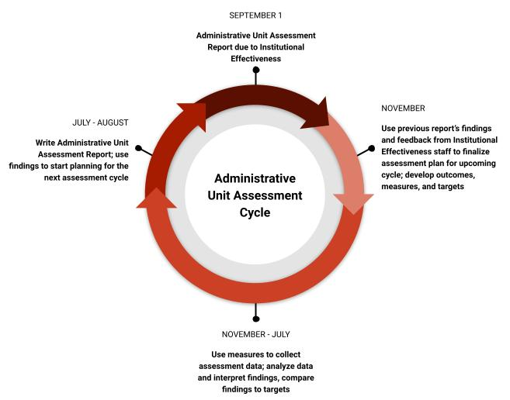
Directions:
- First, please complete the administrative unit summary information below.
- Table 1: Administrative Unit Outcomes (AUOs).
  - Each unit should have a total of 3 to 5 administrative unit outcomes.
  - Please measure and provide findings and comments on findings for at least 3 of your AUOs each year.
  - All AUOs should be measured at least twice in a 5-year period.
  - Please list all of your AUOs and their corresponding measures and targets, in the report document, even those that were not measured this year.
  - An action plan should be provided for AUOs where targets were not met. If all targets are met, please provide an action plan for at least one AUO.
- Table 2: Student Learning Outcomes (SLOs).
  - Not all administrative units will have SLOs. If your unit directly impacts student learning and development, you should be measuring at least 1 SLO each year.
  - If your unit has SLOs, please list all of them with their corresponding measures and targets, even those that were not measured this year.
  - Please also provide findings and comments on findings for any SLOs measured during the academic year.
  - Please provide an action plan for any SLO where targets were not met.
Reports for the 2020-2021 academic year are due by September 1, 2021. If you need assistance, please do not hesitate to contact Lauren Bryant, Assistant Director of Institutional Effectiveness, at labryant@vt.edu or 540 231 1989.

Unit Summary:
Academic Year
Administrative Unit Name
Administrative Unit Lead
Assessment Point of Contact
Mission Statement

Table 1: Administrative Unit Outcomes (AUOs)

Administrative Unit Outcomes (AUOs)  Please include all of your AUOs, even those not measured this year. | Assessment Measures  Please include a measure for each AUO, even those not measured this year. | Targets  Please include a target for each AUO, even those not measured this year. | Findings  Please include findings for each AUO measured this year, and please state if your target was met. | Comments on Findings  For each AUO measured: What do these findings mean to your unit? When do you plan to measure the outcome again? Are you considering making changes to your assessment plan based on these findings? | Action Planning  Is the program planning any changes or other improvements based on these findings? An action plan should be included for all AUOs with unmet targets. | Comments on Past Action Planning  What action plans have been implemented for this outcome in the past? How have those changes affected unit quality or efficiency?
AUO #1:

AUO #2:

AUO #3:

AUO #4:

AUO #5:

Table 2: Student Learning Outcomes (SLOs) – if applicable

Student Learning Outcomes (SLOs)  Please include all of your SLOs, even those not measured this year. | Assessment Measures  Please include a measure for each SLO, even those not measured this year. | Targets  Please include a target for each SLO, even those not measured this year. | Findings  Please include findings for each SLO measured this year, and please state if your target was met. | Comments on Findings  For each SLO measured: What do these findings mean to your unit? When do you plan to measure the outcome again? Are you considering making changes to your assessment plan based on these findings? | Action Planning  Is the program planning any changes or other improvements based on these findings? An action plan should be included for all SLOs with unmet targets. | Comments on Past Action Planning  What action plans have been implemented for this outcome in the past? How have those changes affected student learning?
SLO #1:

SLO #2:

SLO #3:

General Questions – optional
- Is there any additional information not included in your assessment plan that you would like to share that describes efforts you have made to improve unit quality, efficiency, and/or student learning?
- What have you learned about your unit and/or students as a result of engaging in the assessment process?
- What external factors are driving or informing your assessment practices?
- What help do you need from Institutional Effectiveness with regard to your assessment processes?

