Administrative Unit Assessment Report Template
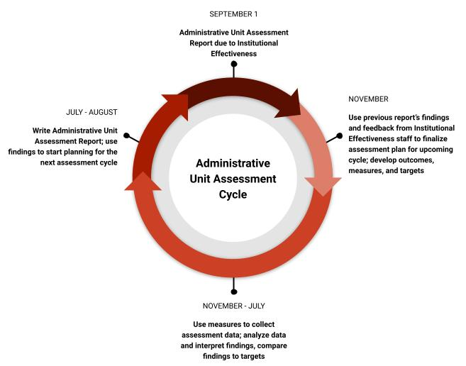
Please read:
- The ultimate goal of the administrative unit assessment process is to seek improvement, not demonstrate performance. In other words, the goal of this process is to document your unit’s efforts to improve its services, products, processes, and functioning. Outcomes should focus on areas that the unit wants to optimize, instead of areas that have already been optimized.
- Please complete the administrative unit summary information below.
- Reminders for Table 1: Administrative Unit Outcomes (AUOs).
  - Prompts are provided in each column header to guide you in completing the template.
  - Each unit should have a total of 3 to 5 AUOs.
  - Please measure and provide findings and comments on findings for at least 3 of your AUOs each year.
  - All AUOs should be measured at least twice in a 5-year period.
  - Please list all of your AUOs and their corresponding measures and targets in the report, even those that were not measured this year.
  - An action plan should be provided for AUOs where targets were not met. If all targets are met, please provide an action plan for at least one AUO.
- Reminders for Table 2: Student Learning Outcomes (SLOs).
  - Prompts are provided in each column header to guide you in completing the template.
  - Not all administrative units will have SLOs. If your unit directly impacts student learning and development, you should be measuring at least 1 SLO each year.
  - If your unit has SLOs, please list all of them with their corresponding measures and targets, even those that were not measured this year.
  - Please also provide findings and comments on findings for any SLOs measured during the academic year.
  - Please provide an action plan for any SLO where targets were not met.
Reports for the 2022-2023 academic year are due by September 1, 2023. Please submit reports via email to Lauren Bryant, Assistant Director of Institutional Effectiveness, at labryant@vt.edu. Please also feel free to contact Lauren for additional assistance or guidance. For examples of AUOs and SLOs based on unit type, FAQs, or to see our data visualizations based on AUA data, please visit: https://aie.vt.edu/institutional-effectiveness/administrative-unit-assessment.html

Unit Summary:
Academic Year
Administrative Unit Name
Administrative Unit Lead
Assessment Point of Contact
Mission Statement

Table 1: Administrative Unit Outcomes (AUOs)

Administrative Unit Outcomes (AUOs)  Please include all of your AUOs, even those not measured this year. | Assessment Measures  Please include a measure for each AUO, even those not measured this year. | Targets  Please include a target for each AUO, even those not measured this year. | Findings  Please include findings for each AUO measured this year, and please state whether or not each target was met. | Reflecting on Findings  For each AUO measured: What do these findings mean to your unit? When do you plan to measure the outcome again? Are you considering making changes to your assessment plan based on these findings? | Action Planning  Is the unit planning any changes or other improvements based on these findings? An action plan should be included for all AUOs with unmet targets. | Reflecting on Past Action Planning  What action plans have been implemented for this outcome in the past? How have those changes affected unit quality or efficiency?
AUO #1:

AUO #2:

AUO #3:

AUO #4:

AUO #5:

Table 2: Student Learning Outcomes (SLOs) – if applicable

Student Learning Outcomes (SLOs)  Please include all of your SLOs, even those not measured this year. | Assessment Measures  Please include a measure for each SLO, even those not measured this year. | Targets  Please include a target for each SLO, even those not measured this year. | Findings  Please include findings for each SLO measured this year, and please state whether or not each target was met. | Reflecting on Findings  For each SLO measured: What do these findings mean to your unit? When do you plan to measure the outcome again? Are you considering making changes to your assessment plan based on these findings? | Action Planning  Is the unit planning any changes or other improvements based on these findings? An action plan should be included for all SLOs with unmet targets. | Reflecting on Past Action Planning  What action plans have been implemented for this outcome in the past? How have those changes affected student learning?
SLO #1:

SLO #2:

SLO #3:

Feedback on Administrative Unit Assessment – optional
- What can Institutional Effectiveness do to better support you and your unit in this process?
- What challenges or barriers are making this process more difficult or less useful for you and your unit?
- What changes would you make to the Administrative Unit Assessment process?
- What additional information not included in the tables above would you like us to know?

